**Enhancing Road Safety System Using Machine Learning Techniques**

Dr.C.R.Dhivyaa1, K.Mugunthan2, Aaroon D Sanju3, P.Naveen4

*1Assistant Professor, Department of CSE, Nandha College of Technology, Erode-638052*

*2UG Student, Department of CSE, Nandha College of Technology, Erode-638052*

*3UG Student, Department of CSE, Nandha College of Technology, Erode-638052*

*4UG Student, Department of CSE, Nandha College of Technology, Erode-638052*

*1crdhivyait@gmail.com,2mugunthkumar99@gmail.com, 3aaroonsanju5@gmai.com, 4naveencom872@gmai.com*

**Abstract:** - The most important aspects in an accident investigation are the license plate detection and driver drowsiness detection. License plate detection uses the novel algorithm.[1] It is divided into three stages: license plate detection, individual number and character extraction, and number and character recognition. The Gaussian blur filter is used to remove noise in the image and then using modified canny algorithm the numbers and characters are recognized using k-nearest neighbor classifier. Driver drowsiness detection algorithm is based on the state of eyes of the driver which is determined by his iris visibility. If driver’s eyes remain in one state either open or closed longer than expected time as well as if the driver is not looking straight front, it is an indication that driver is drowsy and then the system warns the driver by making alarm. It uses Viola_Jones algorithm to detect the objects such as nose, mouth or upper body and captures the image. After capturing an image, rectangular eyes area was adjusted to reduce the noise. The drowsiness detection is done based on the conditions like Black to White pixels ratio, number of pixels in the column greater than the threshold value and eye's shape. The Alcohol sensor fixed on helmet is used to prevent drink and drive scenarios.

Keywords –Machine Learning, classification, OCR, ESP8266, Drowsiness, OpenCV,KNN

**1. INTRODUCTION**

We know that young generation prefers bikes and motorcycle over four wheelers. Moreover speeding and drunk driving have become common issues.[3]Due to lack of our experience or focus and violation of traffic rules, result in several accidents. So with the help of technology problems mentioned above are avoided and their effects are minimized. The idea of developing this project comes from our social responsibility towards society.

Almost all vehicle are captured in CCTV cameras. So it is not easy to detect and recognize license plate correctly. To overcome this problem, we propose an algorithm that automatically recognizes license plate using a CCTV camera footages. A license plate detection and recognition is one of important processes in investigating a car accident.[2] The new license plate format is made up of ## (letter) #### where # is a number. . [9]

Driver Drowsiness Detection is one of the car safety feature that helps prevent accidents caused by the drowsy driver. According to the Central Road Research Institute (CRRI) in Indian says that 40% of highway accidents occur due to drivers dozing off. Thus, driver drowsiness detection feature is very important to prevent accidents and save lives.

However the main goal of our project is to make it mandatory for the rider to wear a helmet during the ride meanwhile providing solutions to other major issues for accidents.

**2. RELATED WORK**

**2.1 DROWSYNESS DRIVER DETECTION**

By using a non-intrusive machine vision based concepts, drowsiness of the driver detected system is developed. Many existing systems require a camera which is installed in front of driver. .[2] It points straight towards the face of the driver and monitors the driver’s eyes in order to identify the drowsiness. For large vehicle such as heavy trucks and buses this arrangement is not pertinent. Bus has a large front glass window to have a broad view for safe driving. If we place a camera on the window of front glass, the camera blocks the frontal view of driver so it is not practical. If the camera is placed on the frame which is just about the window, then the camera is unable to detain the anterior view of the face of the driver correctly. [7]The open CV detector detects only 40% of face of driver in normal driving position in video recording of 10 minutes. In the oblique view, the Open CV eye detector (CV-ED) frequently fails to trace the pair of eyes. If the eyes are closed for five successive frames the system concludes that the driver is declining slumbering and issues a warning signal. Hence existing system is not applicable for large vehicles. In order to conquer the problem of existing system, new detection system is developed in this project work.

**2.2 AUTOMATIC NUMBER PLATE DETECTION AUTOMATIC NUMBER PLATE DETECTION**

ANPR System using OCR at the hub of the system is the OCR (Optical Character Recognition system) which is used to extract the alphanumeric characters present on the number plate. . [1] There are only two components in the system, the web cameras at the front-end and the remote computers at the back-end to process the data. The remote computers pre-process the perform operations like OCR on the stored images sent by the cameras at the lane-level An example of a server farm can be the London Congestion Charge project. [9] The remote computers can be linked with the database which stores the details of the car owners and thus the required information can be obtained. Using this information the culprit can be caught.

The existing system using OCR was found to have the following drawbacks:

1. Misidentification:

2. Hazy images:

3. Flaws in angular detection

**2.3 SMART HELMET BIKE STARTER WITH ALCOHOL DETECTION**

The related project basically has a wired communication and is connected to a Microcontroller. This prototype uses sensors to detect a helmet or alcohol detection and the communication hardware is used to automatically turn the ignition off. The other existing system is controlling the speed in which the biker is going in.[3]The helmet has been fixed with all the components and sensors that read the speed of the bike and accordingly instruct the rider to reduce or increase the speed based on the obstacles ahead the bike. First we have to ensure that weather rider is wearing helmet or not.

This has following disadvantages:

* Rider does not wear helmet in regions where traffic checking is not done.
* Testing alcohol content present in blood in each individual rider in big countries like India is impossible.
* Difficulty of implementation of traffic rules by traffic police.

**3. PROPOSED CLASSIFICATION**

**3.1 DROWSYNESS DRIVER DETECTION-EUCLEADEN**

Blink detection can be estimated by measuring EAR (Eye aspect Ratio) using OPENCV functions and DLIB’s pre trained Neural network based prediction and detector function.[4]In Figure-1 it shows EAR can be measured from eye coordinates returned from OPENCV using EAR formula given below. Abrupt dip in EAR value against a set threshold can be used for blink detection and micro sleep detection shown in Figure-2.

**Figure 1:** The eye aspect ratio equation.

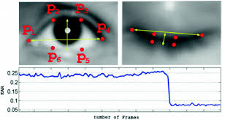

**Figure 2: Results of facial Landmark detection and identification of eye coordinates.**

 **Figure 3: Results of eye blinking detection**

**3.2.AUTOMATIC NUMBER PLATE DETECTION - KNN ALGORITM**

We locate license plates and extract their corresponding regions, then segment these characters on located license plate, and finally use K-nearest neighbour (KNN) classifiers to recognize these segmented characters.[5] The algorithm K-nearest-neighbour (KNN) measures KNN is more appropriate than PNN (Probabilistic Neural Network) algorithm and its recognition rate is up to 96.51 % on average. [11] The recognition rate on average is about 95.87 % for the PNN classifier and about 96.51 % for the KNN classifier. The highest recognition rate for all arguments and block types for PNN are 97.14 %, the highest recognition rate for all case and block types for KNN are 100 %.[8] The highest recognition rate for block type is block 5x5, and the second is 10x5, no matter which classifier. Their recognition rates are 96.97 % (PNN) and 99.77 % (KNN), respectively. .[24]

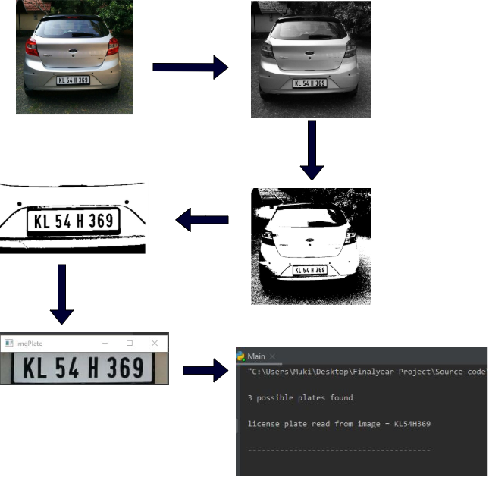

**Figure 4: Steps of detecting number plate**

**3.3 SMART HELMET BIKE STARTER WITH ALCOHOL DETECTION**

The smart helmet checks if the rider has consumed alcohol and driving. If the rider is consumed alcohol then the ignition of the bike will be turned of and the hence not letting the rider to ride the bike. .[3] In this system we use an ESP8266 microcontroller interfaced with MQ3 Alcohol sensor and it is used to monitor user’s breath and constantly sends signals to microcontroller.[6] The ESP8266 microcontroller on encountering alcohol signal from sensor and send the data to motor using RF transmitter and we connect a RF receiver to the motor driver which stops dc motor to demonstrate as engine locking. The proposed system needs a push button to start the engine. If the alcohol is detected the system locks the engine and does not allow the rider to take a ride.

**4. ARCHITECTURE**

* 1. **AUTOMATIC NUMBER PLATE DETECTION**

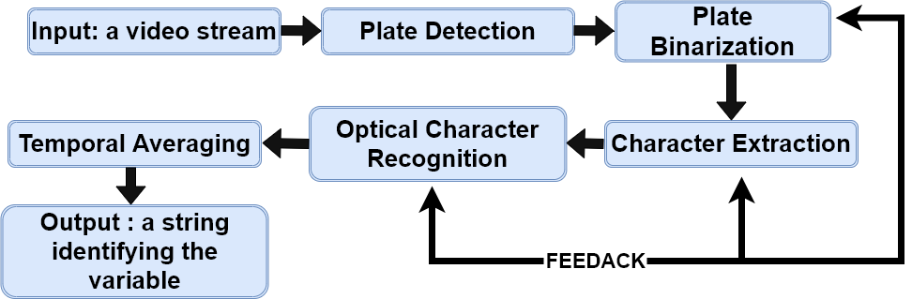

* 1. **DROWSYNESS DRIVER DETECTION**

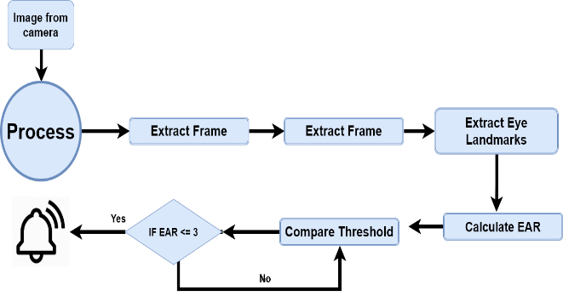

* 1. **SMART HELMET BIKE STARTER WITH ALCOHOL DETECTION**
* **HELMET SECTION**

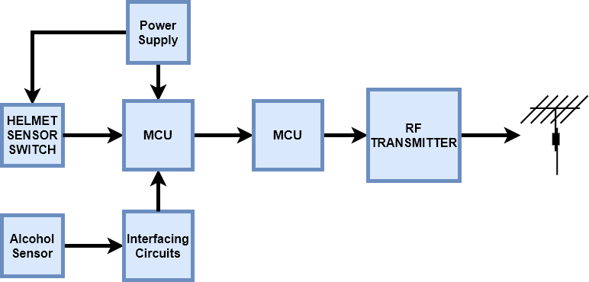

* **BIKE SECTION**

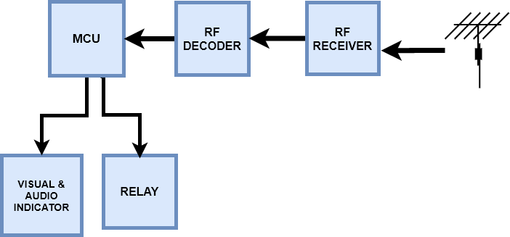

**5. RESULTS AND DISCUSSION**

**5.1 DROWSYNESS DRIVER DETECTION**

**Software Requirements**

* The standards webcam of the HP laptops
* HP laptop (Elite book 840 G1)
* CPU-Core-I5, 2.4 GH
* RAM-8.0 GB
* Graphic card: GeForce GT 230M
* 64-bit windows operating system

The video rendered frames were acquired at the rate of 60 frames per second (also the system was tested on lower and higher frame rates).

The inexpensive hardware was user in order to complete that the proposed approach is efficient and can work under low-quality images generated by the standard laptop webcam.[7]

Table 1 describes the results of the proposed system in this study for six test instances (each experiment instance has been conducted by a different user). [24] The following terms describe the used measures in the experiments:

* Total frame means the total number of frames in each iteration experiment instance
* Detection failure shows that means the count of drowsiness detection failures.
* Correct warning rate of drowsiness detection is defined as in the below equation which is ratio of (Total Frame-Detection Failure) to total frames.

**Figure 5: correct rate**

Figure 5 describes the calculated values of the correct rate for each tested instance.the correct warning rate of drowsiness detection is higher than 99.2% and the average correct rate can achieve 99.45%.

Figure 6 described the calculated ratio of precision for each instance:

**Figure 6: Precision rate**

The gained result describes the efficiency of the proposed system of learning. The result varies with respect to the following factors:

* No. of captured frames
* Size of the eye
* Eye clearance (with or without eyeglass)

Furthermore, the training dataset play the most important role in indicating the performance of the system.[8] The performance can be directly proportional with quantity (number of the eye images) and the quality (variety of eye images) of the training data. .[23]

**Figure 7: Correct rate for each experiment instance**

**Figure 7: Precision rate for each experiment instance**

The analysis of results demonstrated the effectiveness of the proposed methodology. In this methodology the most efficient techniques and promising has selected and used in the developed system (Haar Face detection algorithm, .[24] Haar cascade eye detection algorithm, Support Vector Machine for machine learning classification). As we compared with other similar researches in the literature paper achieved a correct rate of 93.74%, whereas our approach achieved correct rate of 99.45%.

**6.2. AUTOMATIC NUMBER PLATE DETECTION**

We collected 30 images of Indian cars having license plates in different light conditions.[9] We divided those images in to 3 of the groups and each of the group has 10 images. We have named those groups A, B and C respectively.[22]. We tested our own test cases on these groups which are further discussed in following sections.

**License Plate Detection**

As we go through the previously in Architecture and Implementation chapters, we have implemented two algorithms for license plate detection: Haar-Training and KNN. We tested our own test cases on these methods separately to compare their performance.

**License Plate Detection through Haar-Training**

|  |  |  |  |
| --- | --- | --- | --- |
| Groups Plates | Total License Plates | No. of Detected License | Detection Rate (%) |
| Group A | 10 | 8 | 0.8 |
| Group B | 10 | 9 | 0.9 |
| Group C | 10 | 9 | 0.9 |
| Results | 30 | 26 | 0.86 |

**Table 1: License Plate Detection through Haar-Training**

**Figure 8: License Plate Detection through Haar-Training**

|  |  |  |  |
| --- | --- | --- | --- |
| Groups Plates | Total License Plates | No. of Detected License | Detection Rate (%) |
| Group A | 10 | 9 | 0.9 |
| Group B | 10 | 10 | 1 |
| Group C | 10 | 10 | 1 |
| Results | 30 | 29 | 0.96 |

**Table 2: License Plate Detection through KNN-Training**

**Figure 9: License Plate Detection through KNN**

Table 1 shows the results of license plate detection through Haar-training.[10] We can analysis through the table that Group A has less detection as compared to other groups but detection rate of haar-training for 3 groups is 0.96.

**License Plate Detection Results through KNN**

Table 2 shows us results that we got through KNN algorithm. Group A has lower detection rate as compared to other groups but detection rate of KNN algorithm against 3 groups is 0.86 which is quite satisfactory.

**Precision of Tesseract-OCR**

We used the KNN algorithm and tesseract-ocr library in combination for LPR..The second column contains those license plates that were extracted in previous section using KNN algorithm.

**Total Numbers of Extracted License Plates**=26

**Correct OCR Results**=22

**Precision of OCR**= (22/26)*100= 84.6%

We can know that the precision of tesseract-ocr results is almost 85 percent, which is quite acceptable. In conclusion, we see from the above results that haar training algorithm has higher detection rate as compared to KNN algorithm but KNN algorithm also shown good results. Our test cases results for KNN also have shown us that it has 85% accuracy for character recognition. Since we shall easily calculate the precision of our License Plate Recognition system. .[21]

**Correct OCR Results**=22

**No. of License Plate used in test cases**=30

**Precision of LRP System**= (22/30)*100= 73%

The calculation shows that the precision of our License Plate Recognition system is 73%.

**License Plate Recognition in Practice, Real Time**

We have chosen 20 cars from university area having standard Swedish license plates and test our license plate recognition application.[11]We tested to find that how many tries it needed to recognize license plate. We gave maximum 3 tries to recognize license plate.

**Total No. of Cars**=20

**Detected License Plates**=17

**Precision of LPR in Real Time**= (17/20)*100=85%

The calculation shows that the precision of our LPR system in real time is 85%.

**6.3. SMART HELMET BIKE STARTER WITH ALCOHOL DETECTION**

As per survey result, most cases of accidents area unit by motor bikes due to drunk and driving. The reason of those accidents are increased because of the absence of helmet or by the usage of alcoholic drinks. . [3] In our proposed system we have a solution to develop an electronic smart helmet system that efficiently checks the wearing of helmet and drunken driving.[15] By implementing this system in real time for riders a safe two wheeler journey is possible which would reduce the head injuries throughout accidents caused from the absence of helmet and additionally reduce the accident rate due to drunken driving still public are safe. .[20] We have a solution to introduce advanced sensors techniques and radio frequency wireless communications are included in this project to make it a good one. [12] Our project efficiently checks the wearing of helmet and drunken driving by the riders. By successfully implementing this system in real time a safe two wheeler journey is possible which would reduce the head injuries during accidents and also reduce the accident rate because of drunken driving**.**

**6. CONCLUSION**

The proposed system is to address a solution to one of the major causes of the road accident, the driver drowsiness; .[22] the proposed solution does tracking the driver’s face and eyes and then the system will notify him when his eyes get closed in order to avoid losing the control of the car and causing traffic accidents.

Real time number plate detection and recognition system that allows to “read” license place information in an automated way and recognize license plate information with an accuracy of over 70%, virtually instantly by simply pointing and detecting the device at a car.[16] Our first and main goal is to develop a LPR system that should have precision over 70%. We have tested precision of our system against images stored in database and real time .The results from case study chapter show that precision of LPR system using images from the real time database is 73 % which is quite satisfactory. The real time testing shows that precision of our LPR system is 85%. the results shows that haar-training has better detection rate (96%) as compared to KNN algorithm (83%) but the statistics of KNN algorithm in Table 2 also show that detection rate of this algorithm is not bad. Other objective was to use standard libraries, so we used tesseract-ocr for Optical Character Recognition and the results from experiments [13] in Table 1 show that it has 86% accuracy. By implementing this proposed project, a safe two-wheeler journey is still possible in which could reduce the head injuries during accidents and also reduce the accident rate due to driving bike after consuming alcohol.[17] The helmet may not be a 100% life saver but still it can definitely the first line of defense for the rider in case of an accident to get safeguards the riders. .[20]

The developed project efficiently ensures:

• Rider is wearing helmet throughout the ride.

• Rider should not be under the influence of alcohol.

• Accident detection.

**6. FUTURE WORK**

* Currently our LPR system is using KNN algorithm for license plate extraction. We can use KNN-training algorithm instead of this algorithm as results from case study shows that it has better detection rate. We are using local database for data storage. For testing implementation of remote data base server can be used through web services.
* It can be used in real time safety system we can simplify the whole circuit into small flexible module later.
* This safety system can be further used to enhance into four-wheeler also by replacing helmet with seatbelt.

**REFERENCES**

1. Prof.Pallavi khare, Rupesh Dudhe, Amolsing Chungade, and Ajit Naykinde, “Advanced license number plate recognition system International Journal of Engineering Research & Technology (IJERT), ICONECT-2015.
2. Anish ANISH LAZRUS1, SIDDHARTHA CHOUBEY2, SINHA G.R.3 , IEEE” International Journal of Machine Intelligence ISSN: 0975–2927 & E-ISSN: 0975–9166, Volume 3, Issue 3, 2011, pp-134-137.
3. Rajneesh, Anudeep Goraya, Gurmeet Singh, “Geert Real Time Drivers Drowsiness Detection and alert System by Measuring EAR,”International Journal of Computer Applications (0975 – 8887) Volume 181 – No. 25, November- 2018.
4. Haoyang Sayeed and A. Perrig, “Secure Wireless Communications: Secret Keys through Multipath,” Proc. IEEE Int’l Conf. Acoustics, SpeechSignal Processing, pp. 3013-3016, Apr.2008
5. One Millisecond Face Alignment with an Ensemble of Regression Trees by Vahid Kazemi and Josephine Sullivan KTH, Royal Institute of Technology Computer Vision and Active Perception Lab Teknikringen 14, Stockholm, Sweden.
6. Real-Time Eye Blink Detection using Facial Landmarks by Tereza Soukupova and Jan Cech, Center for Machine Perception, Department of Cybernetics, Faculty of Electrical Engineering, Czech Technical University in Prague .
7. MarcoJavier Flores, JoséMaría Armingol and Arturo de la Escalera, ―Driver Drowsiness Warning System Using Visual Information for Both Diurnal and Nocturnal Illumination Conditions‖, Springer, EURASIP Journal on Advances in Signal Processing, 2010.
8. Belhassen AkroutWalid Mahdi, ―A Blinking Measurement Method for Driver Drowsiness Detection‖, Springer, Proceedings of the 8th International Conference on Computer Recognition Systems CORES, pp 651-660, 2013.
9. Krajewski J, Sommer D, Trutschel U, Edwards D, Golz M. Steering wheel behavior based estimation of fatigue. The fifth international driving symposium on human factors in driver assessment, training and vehicle design 2009;118-124.
10. Mardi Z, Ashtiani SN, Mikaili M. EEG-based drowsiness detection for safe driving using chaotic features and statistical tests. Journal of medical signals and sensors 2011;1:130–137 [Dino Ienco](http://ieeexplore.ieee.org/search/searchresult.jsp?searchWithin=%22Authors%22:.QT.Dino%20Ienco.QT.&newsearch=true), [Raffaele Gaetano](http://ieeexplore.ieee.org/search/searchresult.jsp?searchWithin=%22Authors%22:.QT.Raffaele%20Gaetano.QT.&newsearch=true), [Claire Dupaquier](http://ieeexplore.ieee.org/search/searchresult.jsp?searchWithin=%22Authors%22:.QT.Claire%20Dupaquier.QT.&newsearch=true),” Land Cover Classification via Multitemporal Spatial Data by Deep Recurrent Neural Networks“ IEEE geoscience and remote sensing letters, vol. 14, no. 10, 2017,pp. 1685 – 1689.
11. National Highway Traffic Safety Administration (NHTSA): Drowsy driving and automobile crashes.
12. International Journal of Operations and Logistics Management www.absronline.org/journals p-ISSN: 2310-4945; e-ISSN: 2309-8023 Volume: 3, Issue: 3, Pages: 222-240 (September 2014) © Academy of Business & Scientific Research .
13. Method of detecting drowsiness level by utilizing blinking duration Kazuhiko Sugiyama a, Tomoaki Nakano a, Shin Yamamoto a, Toshikazu Ishihara a, Hiroyuki Fujii b, Eisaku Akutsu c.
14. Association for Safe International Road Travel (ASIRT), Road Crash Statistics.http://asirt.org/initiatives/informingroadusers/road-safety-facts/road-crash-statistics,2016.
15. Journal of VLSI Signal Processing 23, 497–511 (1999) c °1999 Kluwer Academic Publishers. Manufactured in The Netherlands.
16. Eye Detection Using Morphological and Color Image Processing Tanmay Rajpathaka, Ratnesh Kumar and Eric Schwartzb .
17. A Robust Algorithm for Eye Detection on Grey Intensity Face without Spectacles- JCS&T Vol. 5 No. 3
18. Froba Kebbuck: Audio- and Video-Based Biometric Person Authentication, 3rd International Conference, AVBPA 2001, Halmstad, Sweden, June 2001. Proceedings, Springer. ISBN 3-540-42216-1.
19. Driver Drowsiness Detection using Eye-Closeness Detection (2016 12th International Conference on Signal-Image Technology & Internet-Based Systems).
20. Eye Detection Using Morphological and Color Image Processing Tanmay Rajpathaka, Ratnesh Kumar and Eric Schwartzb
21. A Robust Algorithm for Eye Detection on Grey Intensity Face without Spectacles- JCS&T Vol. 5 No. 3
22. Froba Kebbuck: Audio- and Video-Based Biometric Person Authentication, 3rd International Conference, AVBPA 2001, Halmstad, Sweden, June 2001. Proceedings, Springer. ISBN 3-540-42216-1.
23. Driver Drowsiness Detection using Eye-Closeness Detection (2016 12th International Conference on Signal-Image Technology & Internet-Based Systems)
24. S. Du, M. Ibrahim, M. Shehata, and W. Badawy, “Automatic license plate recognition (ALPR): A state-of-the-art review,” IEEE Trans. Circuits Syst. Video Technol., vol. 23, no. 2, pp. 311-325, 2013.
25. Christos Nikolaos E. Anagnostopoulos, Ioannis E. Anagnostopoulos, Vassili Loumos, and Eleftherios Kayafas, “A License Plate Recognition Algorithm for Intelligent Transportation System Applications”, IEEE, Transactions on Intelligent Transportation Systems. Vol. 7, No.3, September 2006. pp. 377-392.